Index

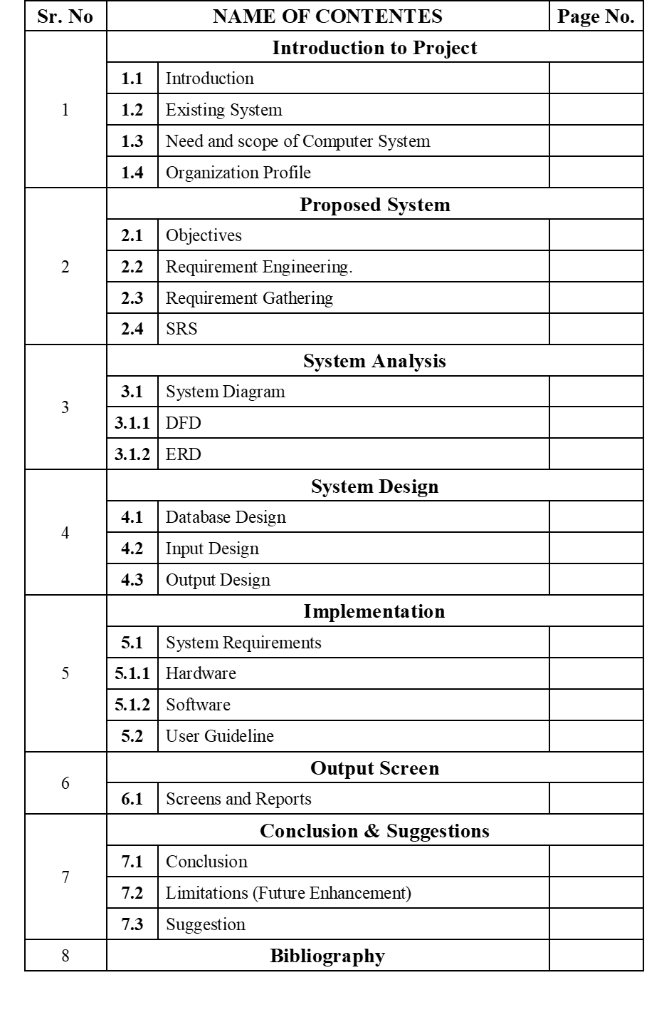

**INTRODUCTION TO**

**SYSTEM**

**INTRODUCTION TO SYSTEM**

**❖Introduction To System:**

* **What is System:**

System involves co-ordinating and overseeing the work activities of others so that their activities are completed efficiently and effectively.

GYM Management System is the process of analysing, producing and evaluating it is different way of promoting a product, service. Digital GYM Management System requires certain core values to be deployed to every element, process and achieve effective and efficient result.

Shops can be described as a unit of producing different items that are used in day to day life. It can be based on the transaction type and items in GYM. The no of transactions involves in system of GYM depends upon the size of the items and exercising items which is required.

**• About project:**

Well Health GYM Application is used to handle all the activity related to the billing in organization that uses this software. Many GYM works on very big Management and it is very hard to manage this manual work. To manage all the billing related activity, we have developed this software. To get easy manipulation in the GYM System owner should have strong network contact of Customers in daily routine. To make a successful owner needs to provide good quality of exercise to the customer. In present system GYM trainer has to do all management work manually. GYM manager keep all transactions information on papers. There is no system to check payment register and this task are very time consuming and tiresome. Keeping all these problems in mind we have developed this system helps the given organization to manage their paper work computerized and they can also retrieve report of last transaction they have completed.

**EXISTING SYSTEM**

* + - In existing system there are lots of paper work and manual processing.
    - Records very carefully as the entire data is written in those book
    - Everything is paper based hence it is very time consuming more than person can‟t access the data at same time
    - There is no system to check the past transactions on any bill, to do this they have to check payment register and this task is too much time consuming and tiresome.
    - The manually system work very difficult and very complex for manages celebration.

**NEED & SCOPE OF COMPUTER SYSTEM**

### Need of the system

* + A single person can work easily and effectively with a computer.
  + The computerized system requires less manpower.
  + Computerized system saves time as well as cost of paper.
  + The system can be user friendly.
  + It gives accurate report.

### Scope of the system

* + To give a better security to software.
  + It will be implemented in different languages.
  + The project would help in effective and Systematic record keeping

that is storing and retrieving of useful data

* + Project will be able to give the report so that Application can make

**PROPOSED**

**SYSTEM**

**PROPOSED SYSTEM**

**Introduction to proposed system:**

Computer is manmade machine. It takes some data as input process as per instruction and give result very quickly and accurately. System is an orderly grouping interdependent component linked together to according to plan to achieve specific objective.

There are many drawbacks in manual system. To overcome these all drawbacks there is need of computerization there are many chances of mistakes while calculation. When calculation is performed on computer, we get more accuracy than manual work. It is easy to generate reports which can received quickly therefore it save the time and energy so fact is reduce man power automatically.

In proposed system when we enter information for new entries, details of event on computer then within fraction of time report will generate. As well as we see total information of particular customer and also we removed particular record from computer and the information about particular field is updated automatically you can create bill receipt on these proposed system. We can see reports at any time on system.

**OBJECTIVES OF SYSTEM**

The main reason behind the development of the system is to overcome the problems and provide the good and quick Reports of system.

## The system consists many objectives as follows:

* + - To increase efficiency and make work effective.
    - This system also uses to current and quick working.
    - To reduce manpower and paperwork.
    - The objective of this system is to store large amount of data with less space and less time.
    - To introduce drawbacks of manual system.
    - To provide good service and give desired and accurate result.
    - There is no loss of data.
    - Using computer software addition, modification, view, deletion of record is quickly possible.

**REQUIREMENT ENGINEERING**

The software requirements are description of features and functionalities of the target system. Requirements convey the expectations of users from the software product. The requirements can be obvious or hidden, known or unknown, expected or unexpected from client’s point of view. The process to gather the software requirements from client, analyze and document them is known as requirement engineering. Requirement Engineering is the process of defining, documenting and maintaining the requirements. It is a process of gathering and defining service provided by the system. The goal of requirement engineering is to develop and maintain sophisticated and descriptive ‘System Requirements Specification’ document

**REQUIREMENT GATHERING**

If the feasibility report is positive towards undertaking the project, next phase starts with gathering requirements from the user. Analysts and engineers communicate with the client and end-users to know their ideas on what the software should provide and which features they want the software to include. It is related to the various ways used to gain knowledge about the project domain and requirements. The various sources of domain knowledge include customers, business manuals, and the existing software of same type, standards and other stakeholders of the project.The techniques used for requirements elicitation include interviews, brainstorming, task analysis, prototyping, etc. Elicitation does not produce formal models of the requirements understood. Instead, it widens the knowledge domain of the analyst and thus helps in providing input to the next stage.

**SOFTWARE REQIREMENT SPECIFICATION**

A System Requirements Specification (SRS) (also known as a Software Requirements Specification) is a document or set of documentation that describes the features and behaviour of a system or software application. It includes a variety of elements that attempts to define the intended functionality required by the customer to satisfy their different users. In addition to specifying how the system should behave, the specification also defines at a high-level the main business processes that will be supported, what simplifying assumptions have been made and what key performance parameters will need to be met by the system. Depending on the methodology employed (agile v s waterfall) the level of formality and detail in the SRS will vary, but in general an SRS should include a description of the functional requirements, system requirements, technical requirements, constraints, assumptions and acceptance criteria. Each of these is described in more detail below:

## Functional And System Requirements

This section usually consists of a hierarchical organization of requirements, with the business/functional requirements at the highest-level and the detailed system requirements listed as their child items.

## Technical Requirements

This section is used to list any of the "non-functional" requirements that essentially embody the technical environment that the product needs to operate in, and include the technical constraints that it needs to operate under. These technical requirements are critical in determining how the higher-level functional requirements will get decomposed into the more specific system requirements.

## System Qualities

This section is used to describe the "non-functional" requirements that define the "quality" of the system. These items are often known as the "ileitis" because most of them end". They included such items as: reliability, availability, serviceability, security, scalability, main ability. Unlike the functional requirements (which are usually narrative in form), the system qualities usually consist of tables of specific metrics that the system must meet to be accepted.

## Constraints And Assumptions

This section will outline any design constraints that have been imposed on the design of the system by the customer, thereby removing certain options from being considered by the developers. Also this section will contain any assumptions that have been made by the requirements engineering team when gathering and analysing the requirements. If any of the assumptions are found to be false, the system requirements specification would need to be re-evaluated to make sure that the documented requirements are still valid.

## Acceptance Criteria

This section will describe the criteria by which the customer will "sign-off" on the final system. Depending on the methodology, this may happen at the end of the testing and quality assurance phase, or in an agile methodology, at the end of each iteration. The criteria will usually refer to the need to complete all user acceptance tests and the rectification of all defects/bugs that meet a pre-determined priority or severity threshold

**SYSTEM ANALYSIS**

**SYSTEM ANALYSIS**

After analysing the requirements of the task to be performed the next step is to analyse the problem and understand its context. The first activity in the phase is studying the existing system do the is to understand the requirements and domain of the new system. Both the activities are equally important, but the first activity basis of giving the functional specification sand then successful design of the proposed system. Understanding the properties and requirement sofa new system is more difficult and requires creative thinking and understanding of existing running system is also difficult, improper understanding of present system an lead diversion from solution.

## Analysis model

The model that is basically being followed is the Water Fall Model which states that the phases are organized in a linear order. First of all the feasibility study is done.

Once that part is over the requirement analysis and project planning begins . If system exists one and modification and addition of new module is needed, analyse is of present system can be used as basic model. The design starts after the requirement analysis is complete and the coding begin after the design is complete. Once the programming is completed, the testing is done.

In this model the sequence of activities performed in as software development project are: -

* Requirement Analysis
* Project planning
* System design
* Detail design
* Coding
* Unit testing
* System integration & testing

Here the linear ordering of these activities is critical. End of the phase and the output of one phase is the input of other phase. The output of each phase is to be consistent with the overall requirement of the system. Some of the qualities of spiral model are also incorporated like after the people concerned with the project review completion of each of the phase the work done.

**FACT FINDING TECHNIQUES**

adopted.

In system under consideration during development phase following methods are

A key part of feasibility is gathering information about the present system. The

analyst knows what information to gather to make of it.

## Questionaries :-

It allow sanely collect information from a group of individuals who may or may not be using the system thus resulting sometimes in irrelevant data & data redundancy.

## Interviews:-

Analysts use interview to collect information from individuals who they considers should be the sources ,who are current users of the existing system .The analyst should have a face conversation with the users & administrator of the system & fixed set of question sis prepared.

## Record Review:-

Consisting of analyzing the previous operations in the company & fore casting the new futures schemes. Record include table name, date &time creation, user login etc.

## Observation :-

If information is not collected from the other fact-finding method, then observation method is used. In this method analyst to observes flow of documents, way the process is carried out steps followed person involved etc.

**FEASIBILITY STUDY**

Feasibility study is a process of evaluating the deciding factors to check whether proposed system is feasible or not. Feasibility is the measure of a how beneficial or practical the development of an information system will be to an organization. The feasibility study is carried out in the following aspects.

1. Technical Feasibility
2. Operational Feasibility.
3. Economic Feasibility.

## Technical Feasibility:

The technical feasibility study carried out for the system determined whether the planned system could be developed & designed in the organization using the existing technology, the technical evaluation also determines whether the existing system can be upgraded to use the new technology & whether the organization has the expertise to use it. The organization is already well Equipped with required hardware & software.

## Operational Feasibility :

Operational feasibility ends at checking if the system will help the user to work in more efficient & accurate manner through all routine operations. The system is made to be comprehensive in nature, using a full menu driven system & appropriate user informative messages & warnings to avoid work of error & facilitate data integrity & consistency. On the contrary, the workload on the user will be lessened to a great extent, as the system is aimed at taking care of the complex procedures & automatic calculations. Thus the system is operationally feasible.

## Economical Feasibility :

While considering economical feasibility, it is checked in points like performance, information & outputs for the system. Economic of the system looks at the financial aspects of the projects. It determines whether the system is economical feasible, in other words it determines whether the investment that goes into the implementation of the system is recoverable. As the hardware & software are already available & no investment is to be made in that direction, the only cost involved is that of implementing the system.

**SYSTEM DIAGRAM**

**SYSTEM DIAGRAM**

**Data Flow Diagram (DFD)**

* **Zero level (Context Level Diagram):**

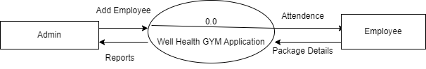

* **First Level Diagram:**

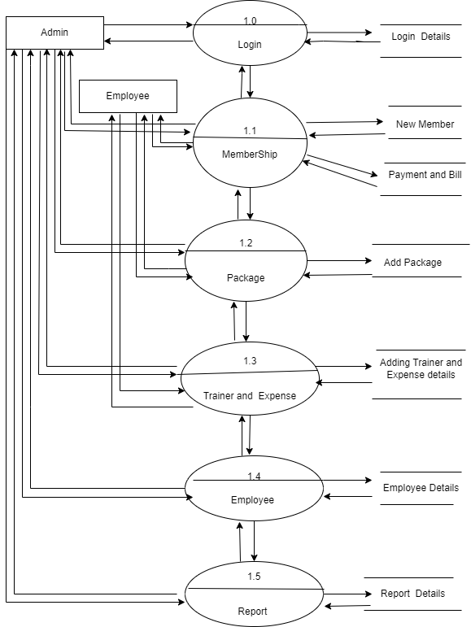

* **Entity Relationship Diagram (ERD)**

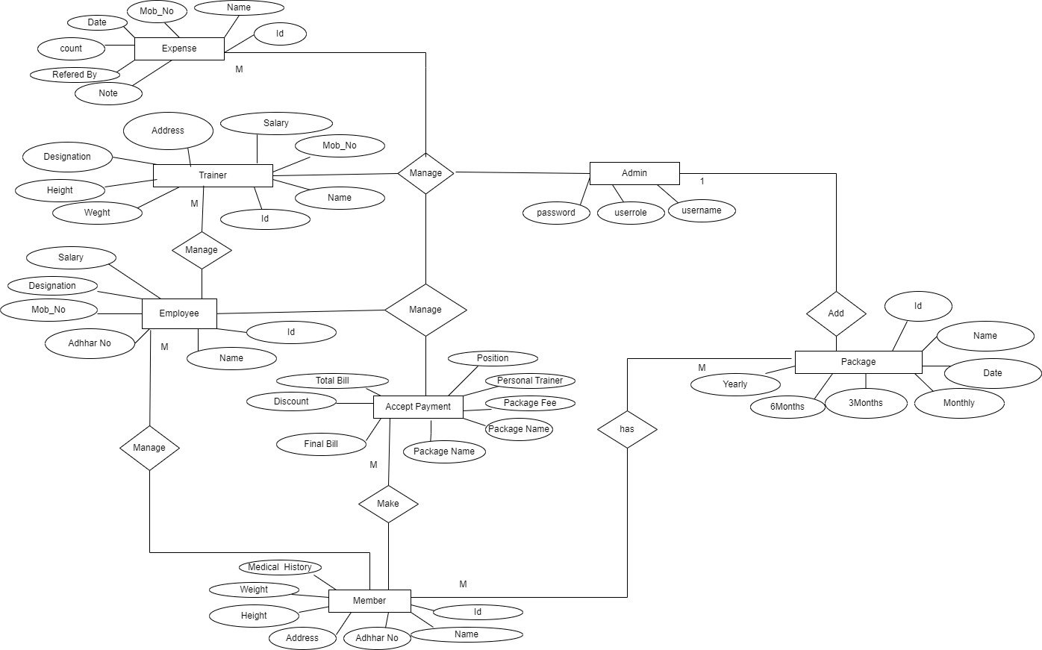

**SYSTEM DESIGN**

**DATABASE DESIGN**

**Table Name:-** login

**Description:-** It Store Login Information.

**Primary key:-** No

|  |  |  |
| --- | --- | --- |
| Column Name | Data type | Constraint |
| **Userrole** | INT | - |
| **UserName** | VARCHAR(45) | - |
| **Password** | VARCHAR(45) | - |

**Table Name:-** Employee_Details

**Description:-** It Store Employee Details.

**Primary key**:- Emp_ID

|  |  |  |
| --- | --- | --- |
| Column Name | Data type | Constraint |
| **Emp_ID** | INT | Primary |
| **Name** | VARCHAR(60) | - |
| **Mob_No** | DECIMAL(10,0) | - |
| **Address** | NVARCHAR(100) | - |
| **Join_Date** | DATE | - |
| **Position** | NVARCHAR(80) | - |
| **Adhhar_No** | DECIMAL(12,0) | - |
| **Salary** | MONEY | - |
| **Bank_Details** | NVARCHAR(80) | - |

**Table Name:-** Member_Details

## Description:-

To Store Member Details.

|  |  |  |
| --- | --- | --- |
| Column Name | Data type | Constraint |
| **Member_ID** | INT | Primary |
| **Member_Name** | VARCHAR(80) |  |
| **Mob_No** | DECIMAL(10,0) | - |
| **Address** | DATE | - |
| **Adhhar_No** | DECIMAL(10,0) | - |
| **Join_Date** | DATE | - |
| **Height** | DECIMAL(4,2) | - |
| **Weight** | DECIMAL(4,2) | - |
| **Medical_History** | VARCHAR(120) | - |
| **Medical_Details** | NVARCHAR(120) | - |
| **RefferdBy** | VARCHAR(80) |  |

**Table Name:-** Expense_Details

**Description:-** To Store Expense Details

|  |  |  |
| --- | --- | --- |
| **Column Name** | **Data type** | **Constraint** |
| **Expense_Id** | INT | - |
| **Expense_Type** | NVARCHAR(60) | Primary |
| **BillPaidBy** | VARCHAR(80) | - |
| **Date** | DATE | - |
| **Expense_Details** | NVARCHAR(45) | - |
| **BillAmount** | MONEY | - |

## Table Name:-

Equipment_Details.

**Description**:- To Store Equipment Details.

|  |  |  |
| --- | --- | --- |
| **Column Name** | **Data type** | **Constraint** |
| **Equi_ID** | INT | Primary |
| **Equi_Name** | VARCHAR(60) | - |
| **Price** | MONEY | - |
| **Date** | DATE | - |
| **MuscleUsed** | VARCHAR(60) | - |
| **Description** | NVARCHAR(80) | - |

**Table Name:-** Package_Details

## Description:-

To Store Package Detailas.

|  |  |  |
| --- | --- | --- |
| Column Name | Data type | Constraint |
| **ID** | INT | Primary |
| **Name** | VARCHAR(60) | - |
| **Date** | DATE | - |
| **MonthlyCharges** | MONEY | - |
| **Package_3Month_Charge** | MONEY | - |
| **Package_6Month_Charge** | MONEY | - |
| **Yearly** | MONEY | - |

**Table Name:-** Trainer_Details

## Description:-

To Stores Trainer Details

|  |  |  |
| --- | --- | --- |
| Column Name | Data type | Constraint |
| **Id** | INT | Primary |
| **Name** | VARCHAR(60) | - |
| **Mob_No** | DECIMAL(10,0) | - |
| **Adhhar_No** | DECIMAL(12,0) | - |
| **Experiance** | NVARCHAR(60) | - |
| **Address** | NVARCHAR(80) | - |
| **Join_Date** | DATE | - |
| **Height** | DECIMAL(6,2) | - |
| **Weight** | DECIMAL(6,2) | - |
| **Designation** | NVARCHAR(80) | - |
| **Salary** | MONEY | - |
| **Bank_Details** | NVARCHAR(80) | - |

**Table Name :-** Enquiry_Details

**Description:-** It Store Enquiry Details.

|  |  |  |
| --- | --- | --- |
| Column Name | Data type | Constraint |
| **ID** | INT | primary |
| **Name** | VARCHAR(60) | - |
| **Mob_No** | DECIMAL(10,0) | - |
| **Count** | INT | - |
| **Date_Of_Enquiry** | DATE | - |
| **Refered_By** | VARCHAR(60) | - |
| **Note** | NVARCHAR(80) | - |

**Table Name:**- Payment_Details

## Description:-

It Stores Payment Details

|  |  |  |
| --- | --- | --- |
| Column Name | Data type | Constraint |
| **Member_ID** | INT | Primary |
| **Package_Name** | VARCHAR(80) | - |
| **Package_Type** | NVARCHAR(40) | - |
| **Package_Fee** | MONEY | - |
| **Trainer_Position** | VARCHAR(80) | - |
| **Trainer_Fee** | MONEY | - |
| **Total_Bill** | MONEY | - |
| **Discount** | INT | - |
| **Payment_Date** | DATE | - |
| **Final_Bill** | MONEY | - |

**INPUT/OUTPUT DESIGN**

* **Splash Screen**

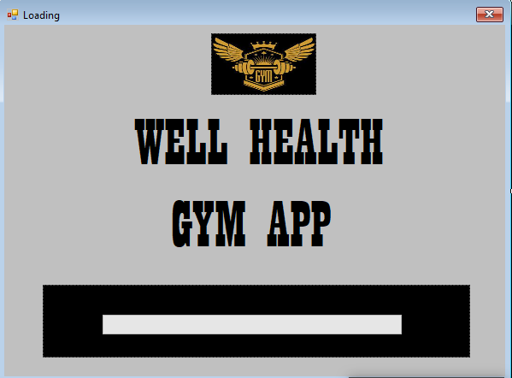

* + **Login Screen**

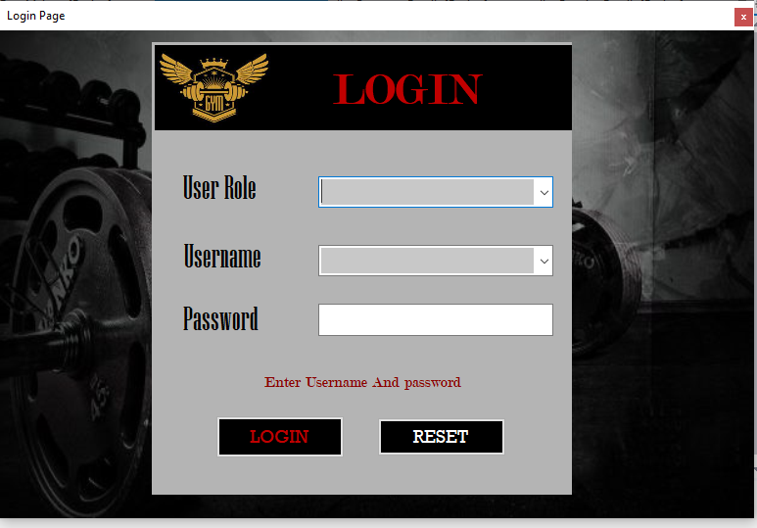

* **Home Page Screen**

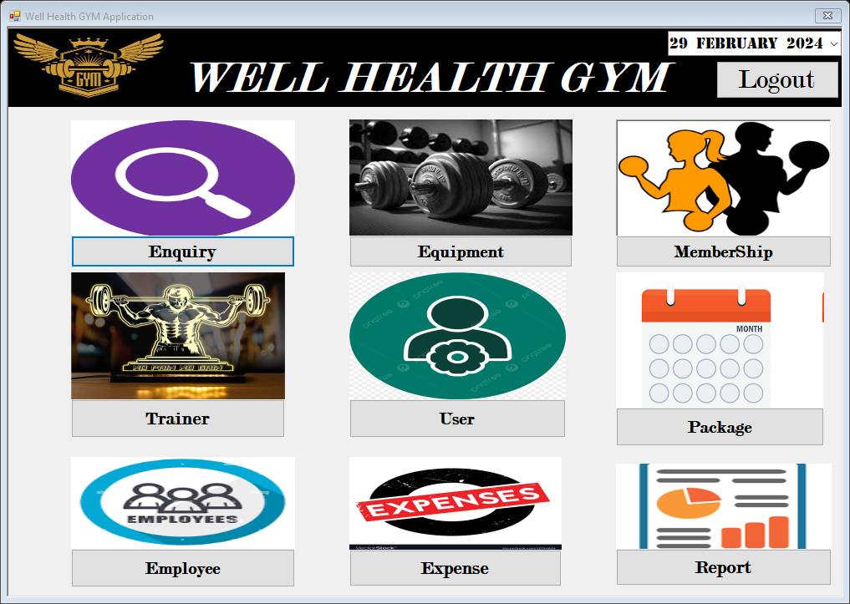

* **Add Member Form**

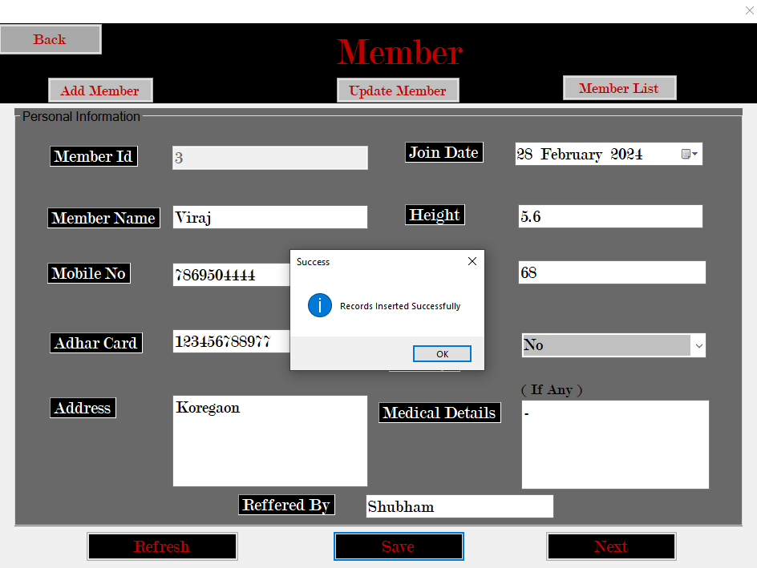

* **Trainer Form**

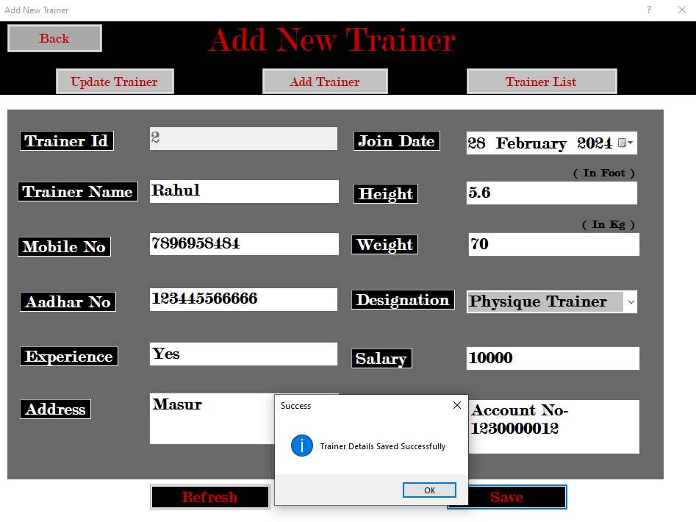

**Package Form** 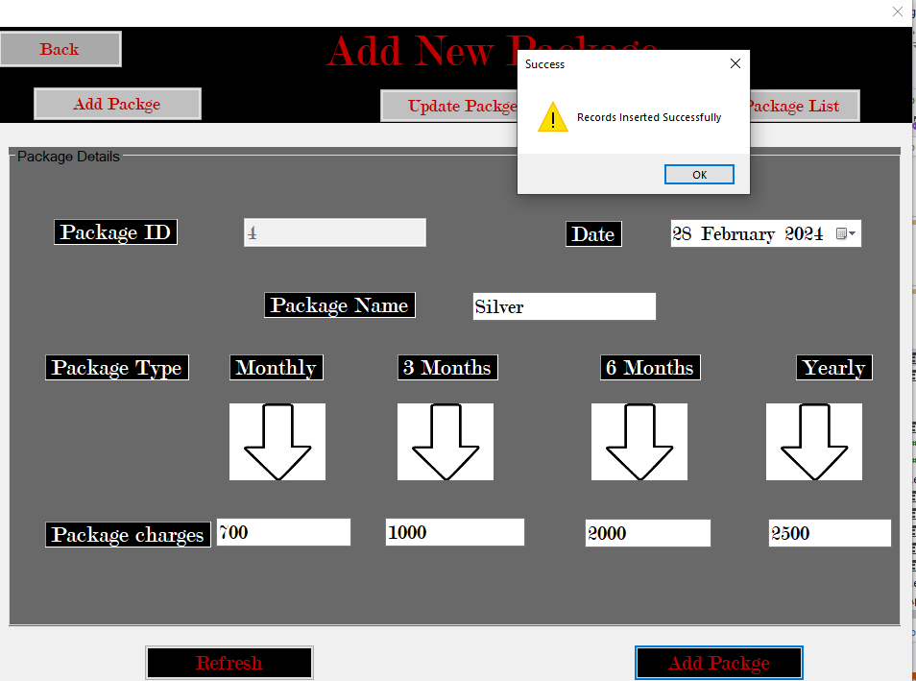

* **Equipment List Form**

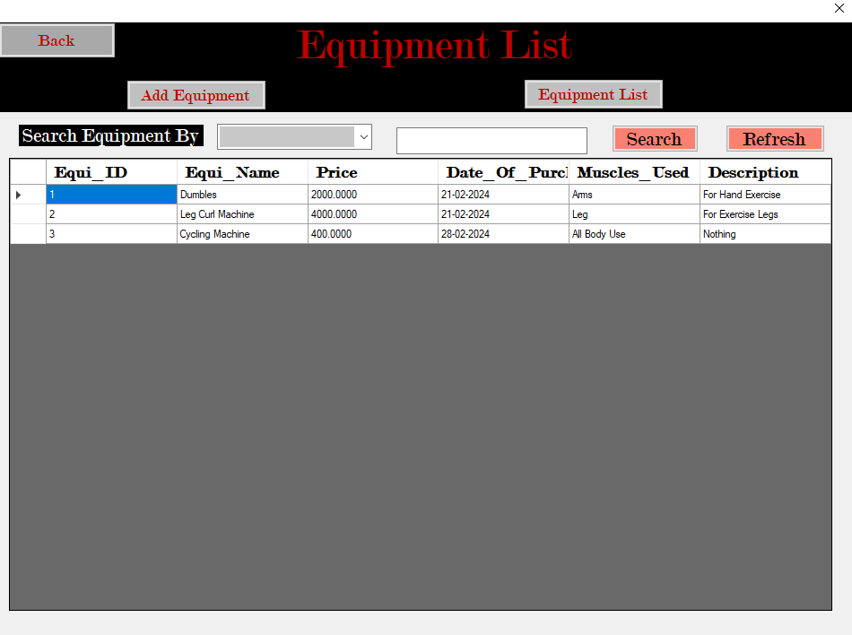

* **Enquiry Form**

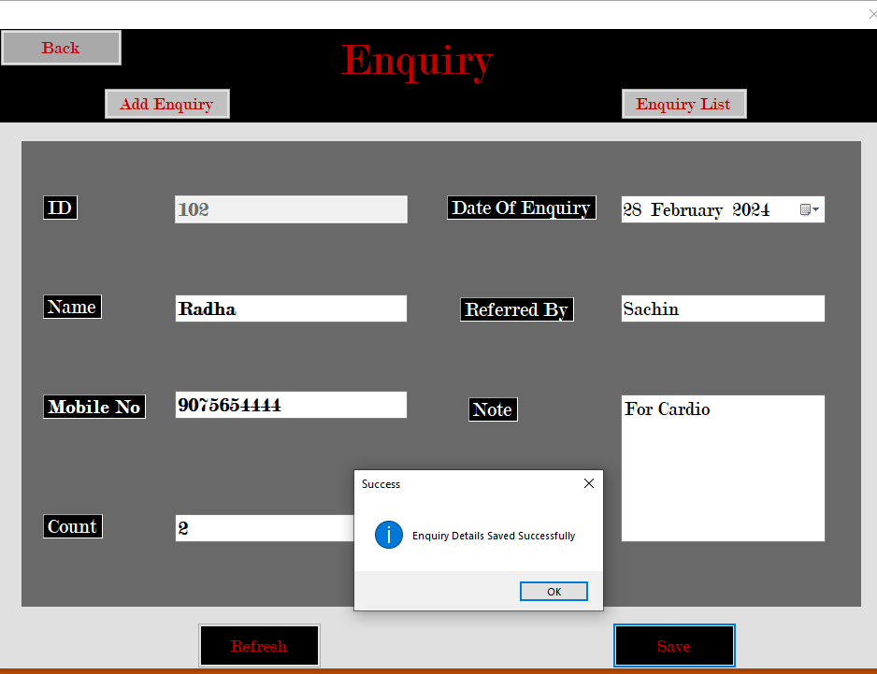

* **Update Member Form**

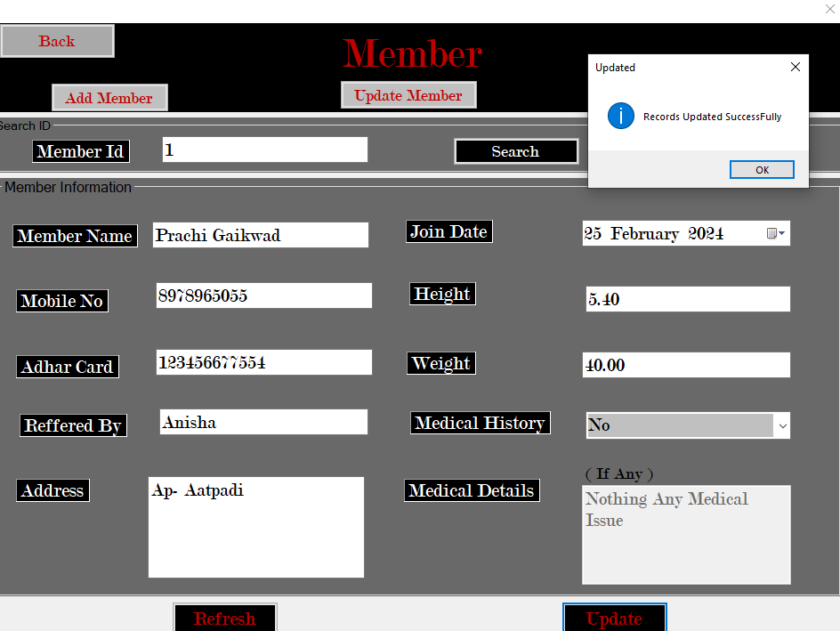

* **Member List Form**

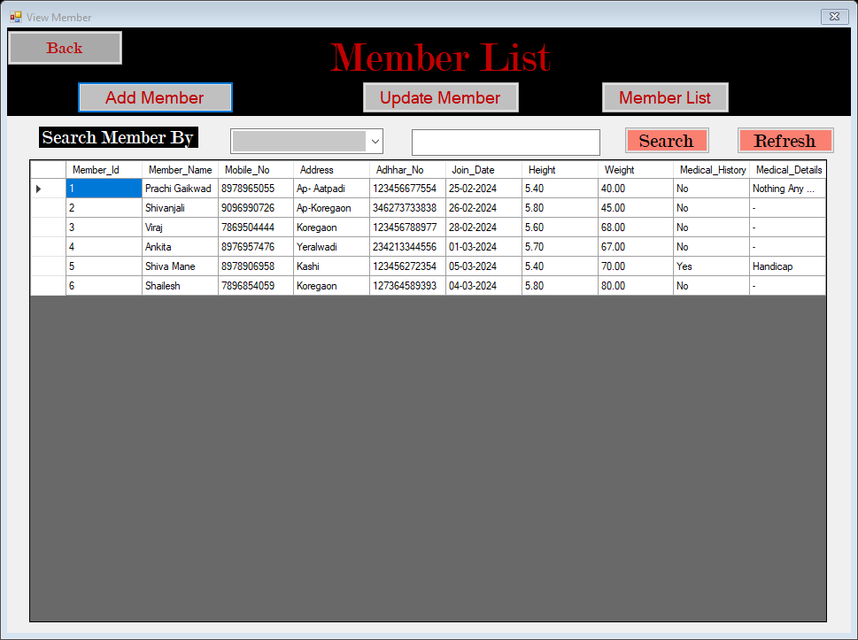

* **Payment Form**

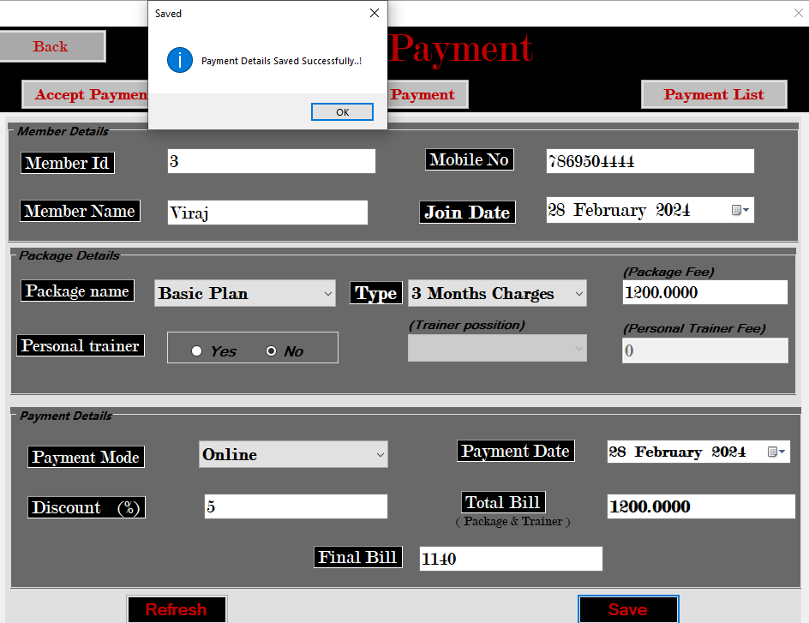

* **Payment List Form**

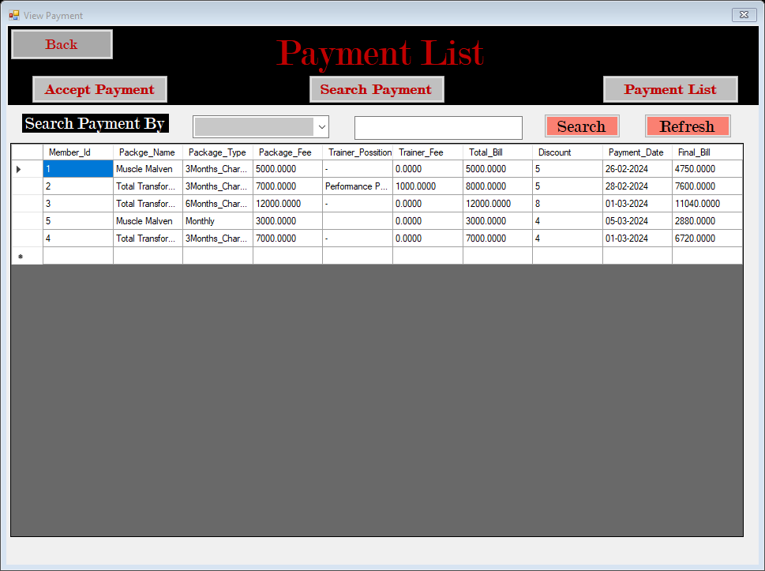

**IMPLEMENTATION**

**IMPLEMENTATION**

Implementation is the carrying out, execution, or practice of a plan, a method, or any design, idea, model, specification, standard or policy for doing something. As such, implementation is the action that must follow any preliminary thinking in order for something to actually happen.

In an [information technology (IT)](https://searchdatacenter.techtarget.com/definition/IT) context, [software](https://searchmicroservices.techtarget.com/definition/software) or [hardware](https://searchnetworking.techtarget.com/definition/hardware) implementation encompasses all the post-sale processes involved in something operating properly in its environment, including analyzing requirements, installation, [configuration,](https://whatis.techtarget.com/definition/configuration) customization, running, testing, systems integrations, user training, delivery and making necessary changes. The word "deployment" is sometimes used to mean the same thing .

For an implementation process to be successful, many tasks between different departments need to be accomplished in sequence. Implementation of a system but the failure of many implementation processes often stems from the lack of accurate planning in the beginning stages of the project due to inadequate resources or unforeseen problems that arise

**SYSTEM REQUIREMENTS**



**Software Requirements**

* Programming Language
* Operating System
* Platform
* Database

C#.Net

Windows 7/8/10 Visual Studio

SQL Server 8

**Hardware Requirements**

* Processor
* RAM
* Hardware Devices
* Hard Disk
* Display

Pentium 4 Processor 3GHZ Min 1GB

Keyboard with Mouse

Min 80GB Hard Disk or above

Standard Output Display

**USER GUIDELINE**

# Splash Form:

This Form Perform the main execution of my system.

# Login Form:

**Main Form:**

This form perform Authorization of my system.

In these form Perform the all details fetch to my system.

After Login you will find following menus.

# Main Form Menus:

* **MemberShip:**

### These Forms display the Member Information

# Package:

# This Form display All about Information of

GYM Package.

# Equipment:

This Form display All about Information of Equipment Details.

# Fee Payments:

This form contains the Applicant fee details.

# Reports:

It generated the all reports of our related details and records.

* Member Bill Report
* Member Report
* Expense Report
* Equipment Report
* Trainer Report
* Employee Report

# Security: -

This menu contains the Lock application and backup & restore.

## Lock Application:

This option is used for security purpose.

## Backup and Restore: -

This form is used for database backup and restore

# Account: -

This menu contains the information related to login accounts.

## New User: -

This form is used for adding new user.

## Change Password: -

This form is used to change the password.

## Remove User: -

Using this form admin can remove the any user.

# Help: -

This menu contain the about system option.

## About System: -

This form contains information about system.

# Utilities: -

This menu contains basic utilities like Calculator, Notepad, Microsoft office etc.

# Exit: -

This menu contains the log out and shut down options for exit.

INTRODUCTION TO VISUAL STUDIO

Visual studio is an Integrated Development Environment(IDE) developed by Microsoft to develop Desktop applications. The GUI(Graphical User Interface), console, web application, mobile application, cloud, and web services. Etc. With the help of this IDE, you create managed code as well as native code. It uses the various platforms of Microsoft software development software like Windows store, Microsoft Silverlight, and windows API, etc. It is not language specific IDE as you can use this to write code in c#, C++ , VB(Visual Basic), Python, Java Script, and many more languages. It provide support for 36 different programming languages. It is available for Windows as well as for macOS.

Evaluation of Visual Studio

The first version of VS(Visual Studio) was released in 1997, named as Visual Studio 97having version number 5.0. The latest version of Visual Studio is 15.0 which was released on March 7,2017. It is also termed as Visual Studio 2017. The supported .Net Framework version in latest Visual Studio is 3.5 to 4.7. Java was supported in old versions of Visual Studio but in the latest version doesn’t provide any support for Java language.

Visual Studio provides developers a features rich development environment to develop high-quality and collaboratively.

Most important highlights are:-

* + Workload-based installer – install only what you need.
  + Powerful coding tools and features – everything you need to build your apps in one place.
  + Multiple language support – code in C++, JavaScript, TypeScript, Python, and more.
  + Cross platform development – build apps for any platforms.
  + Version control integration – collaborate on code with team ma

**SQL SERVER**

SQL is relational database management system developed by Microsoft. SQL is widely used on various industries for building and managing databases. SQL is becoming so popular because of many good reasons –

* SQL Server provides robust security features to protect data such as encryption, authentication, and access control.
* SQL Server is designed to handle large amount of data and cam scale to meet the needs of growing business.

.• SQL works on many operation systems and with many languages including PHP, Python, C, C++, JAVA, C#, etc.

* SQL works very quickly and works well even with large data sets.
* SQL is friendly with multiple programming languages including C#, Java, Python, PHP.
* SQL supports large number of databases up to million of rows or more in a table.
* The default file size limit for a table is 4GB but you can increase this to theoretical limit 8 million TB.
* SQL is customizable. It provides various configuration operations and setting that can be adjusted to meet specific needs and requirements.

.

**OUTPUTS**

**SCREENS AND REPORTS**

# Employee List

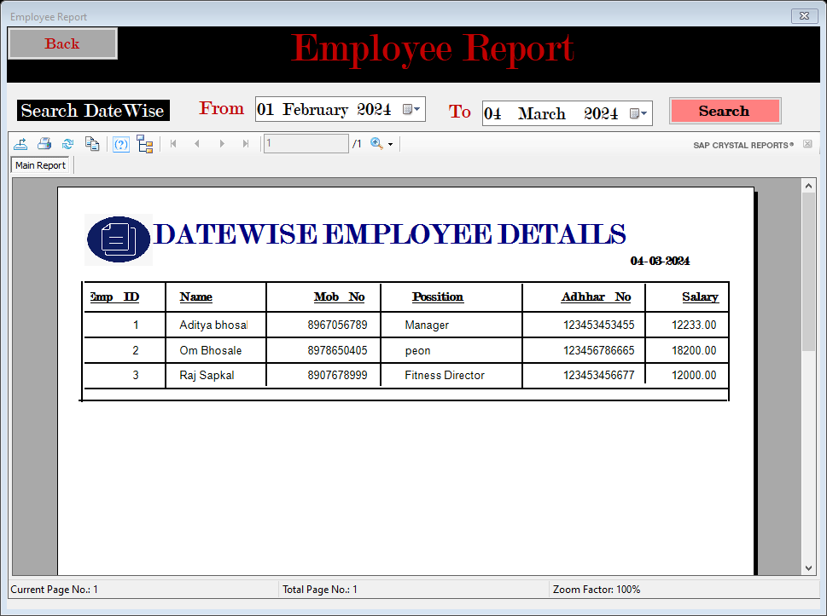

# Expense List

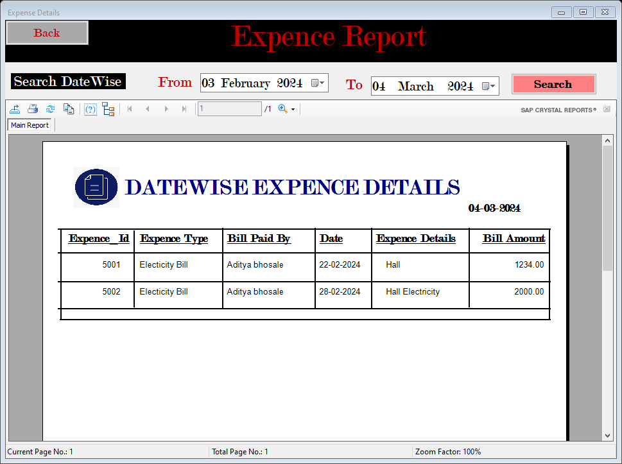

* **Equipment List**

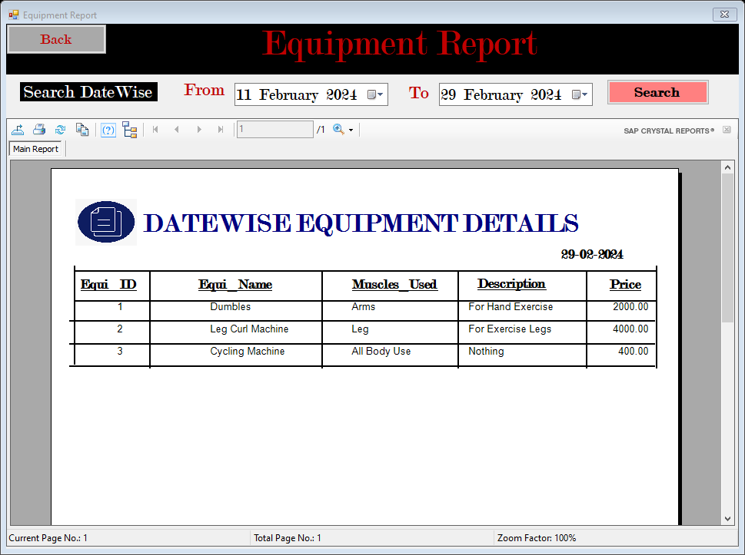

* **Member List**

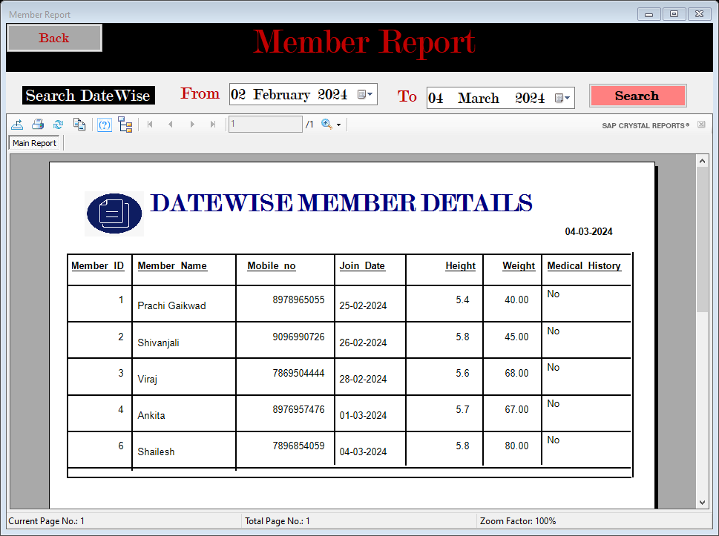

**    **

* **Trainer List**

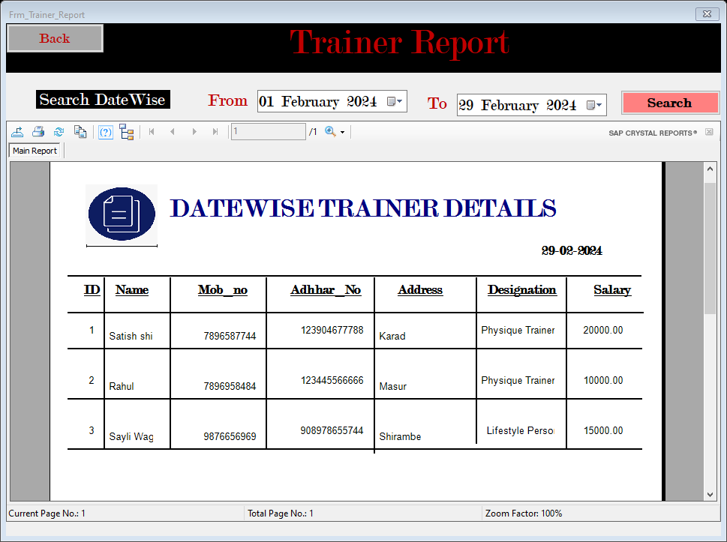

* **Member Bill Report**

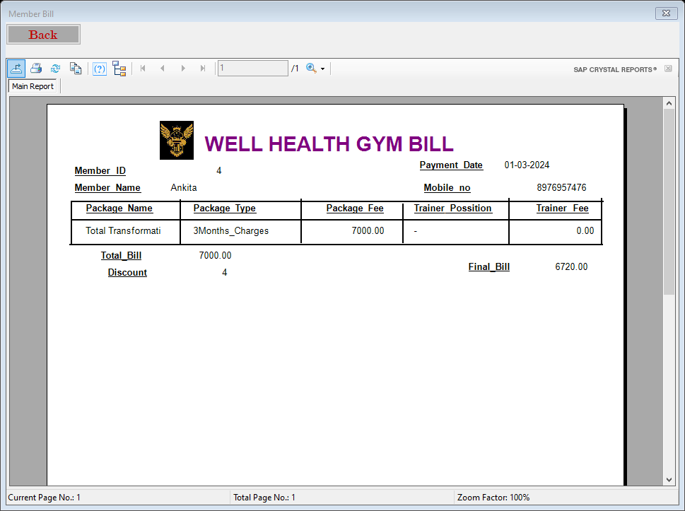

**CONCLUSION AND SUGGESTIONS**

**CONCLUSION**

The project titled as “Well Health GYM Application” is a Desktop based application. This Project Is developed using C# .Net as front end and MS SQL for database in back end . This software provides facility for reporting of Member Information, Trainer Information etc. We are developing such types of the module which help to reduce the GYM work manually & it helps to save the time of the user. considerable reduce the corruption in the transport department keep the GYM Data document safely.

This software is developed with scalability in mind. Additional modules can be easily added when necessary. The software is developed with modular approach. All modules in the system have been tested with valid data and invalid data and everything work successfully. Thus the system has fulfilled all the objectives identified and is able to replace the existing system. The application has been tested with live data and has provided a successful result. Hence the software has proved to work efficiently

**FUTURE ENHANCEMENT**

* The system could reduce the manual work & physical entities of the system.
* We will include more functionality as per the user requirements .
* In Future due to increase in records of database file, data redundancy occurs.
* More modules can be included in future.
* The system can be further enhanced by proposing an advance Facilities.
* We want to improved our home page, as it is the main thing which attracts all users.
* We can host the platform on online server to make it accessible worldwide
* Development and launching of Website and refining existing services and adding more service.

**SUGGESTION**

* + The Proposed System has efficient Management Records and time saving
  + It is also user-friendly.
  + The size of the database increases day-by-day, increasing the load on the database back up and data maintenance activity.
  + Graphical user interface can better.

**BIBLIOGRAPHY**

**BIBLOGRAPHY**



**Books:-**

1. Software Engineering

By Roqer Pressman

1. System Analysis & Design

By E.D.Awad

1. Database System Concept

By Korth Silberschetz